# Intro

* Retrieval – get similar products/documents to the one chosen.
* 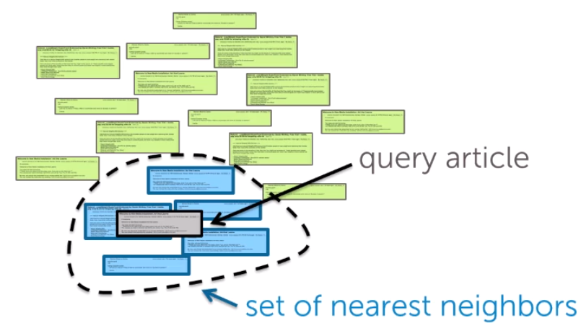
* Clustering – group products/documents in groups.
  + Often it could be an unsupervised learning in contrast to regression and classification

# Nearest Neighbour Search (k-Nearest Neighbours (k-NN algrorithm))

* We define similarity across articales. We compute distances between the article of interest and other articles. We pick the one (ones) that have the smallest distance. In k-NN, we pick k documents with lowest distances
* Document representation
  + Bag of words model – count all word. Problem is that focus will be on common words like ‘the’, ‘in’ and rare words like ‘volcano’ would be lost
  + TF-IDF – term frequency – inverse document frequency. Local frequency (word count in a document) / global frequency (word count in all documents). Thus, unique words will become more important.
* Distances:
  + Euclidean distance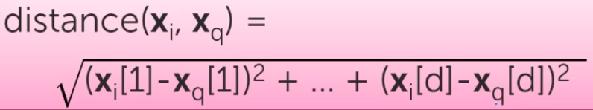
    - Both magnitude and direction are taken into account
  + Weigth features differently -> e.g. abstract and title are more important than body
  + Scaled euclidean distance 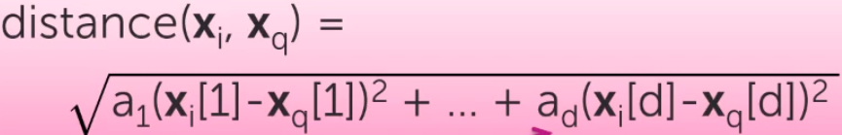
  + Cosine similarity = cos(theta) = 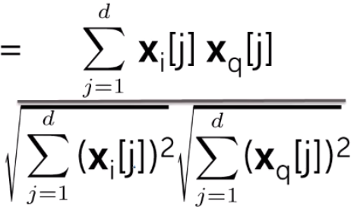 = 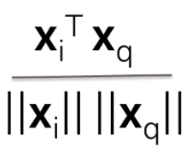 = 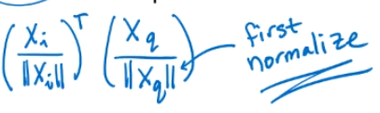
    - Vectors are normalized – their length is made to 1
    - Cosine similarity looks only on direction (co-direction) of vectors, but ignores their magnitude (ignores length of documents)
    - Cosine similarity can make 1 tweet similar to 1 long article. Thus, in practice it is common to compare items (documents) of similar length and not normalizing them
    - In general cosine similarity = [-1,0,1] where 1 is maximum similarity, where -1 means opposite directions and 0 means orthogonality. For only positive features (like tf-idf) cosine similarity = (0,1)
  + Different metrics should be used for different purposes. For the contents of a short text, can use cosine similarity. But for numberical features use euclidean distance
* k-NN complexity:
  + brute force is very computationally expensive, especially if we often send querries
* KD-trees:
  + KD-trees allow splitting data in groups that would make search much faster
  + KD-trees work fine when we have low or medium dimensionality 
  + Grouping data points in boxes and storing this infor in a decision tree
  + 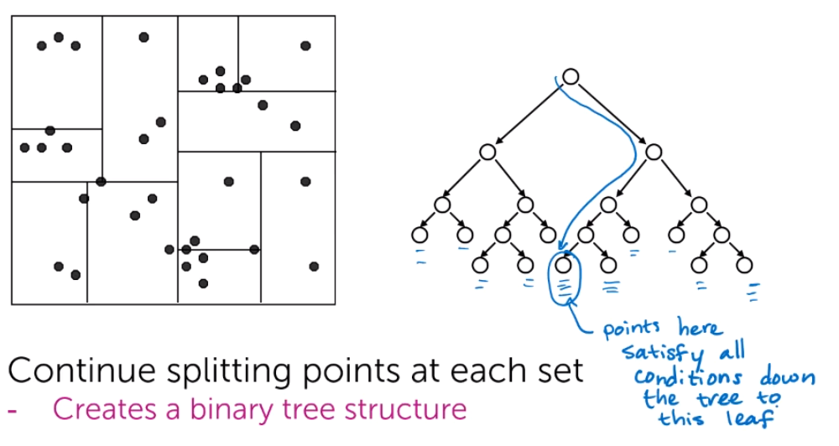
  + 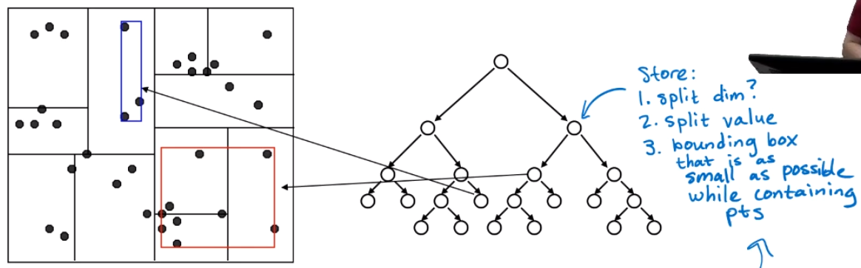
  + Options
    - Which dimension to split on?
      * The widest
    - What value split at?
      * Median or center of the box
    - When do we stop?
      * Fewer than m points left OR box hits minimum width
  + Algorithm:
    - 1) Find our query point: Essentially we store all points in the leafs or a tree. To find the query point, we start from top of the tree and find where our query point is located.
    - 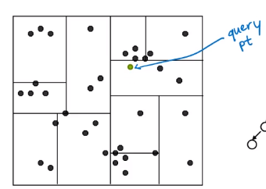
    - 2) Looking for nearest neighbour in the same node/box/leaf
    - 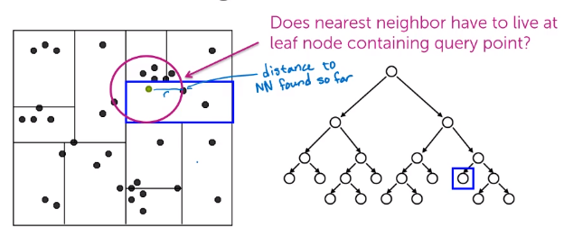
    - 3) Looking for closest NNs in other leafs nearby
    - 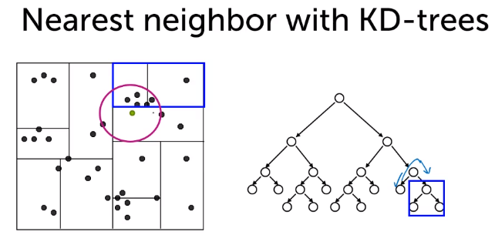
    - To optimize search here, we calculate the distance to boundary box. If this distance is higher than the smallest distance so far, than we ignore it (prune it). Otherwise, we will start computing distances to the points in that box:
    - 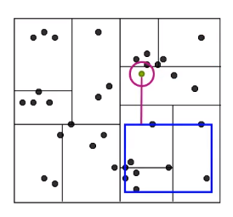
    - 4) We look to other boxes, and can prune them effectively:
    - 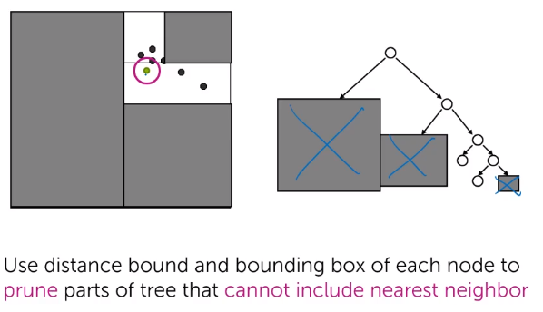
  + Complexity:
    - O(log N) – O(N)
    - In general much more efficient than brute. Unless we are very unlucky, and that the structure of KD-trees is really bad:
    - 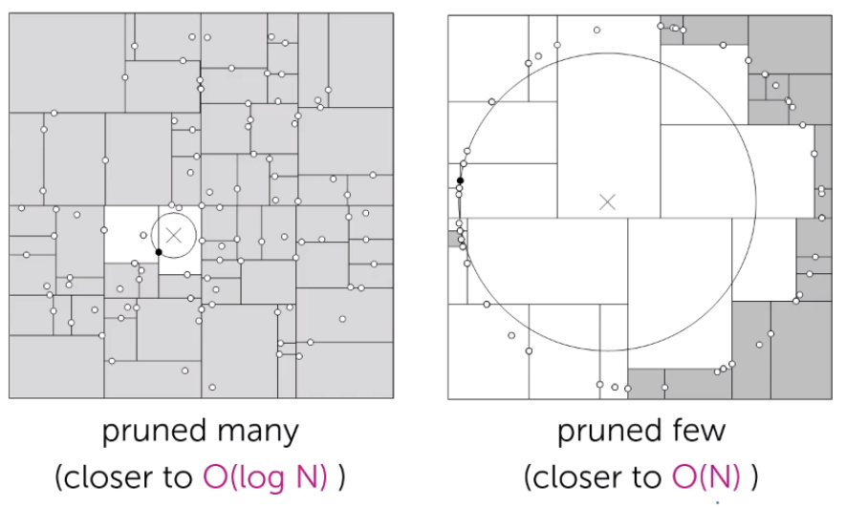
    - 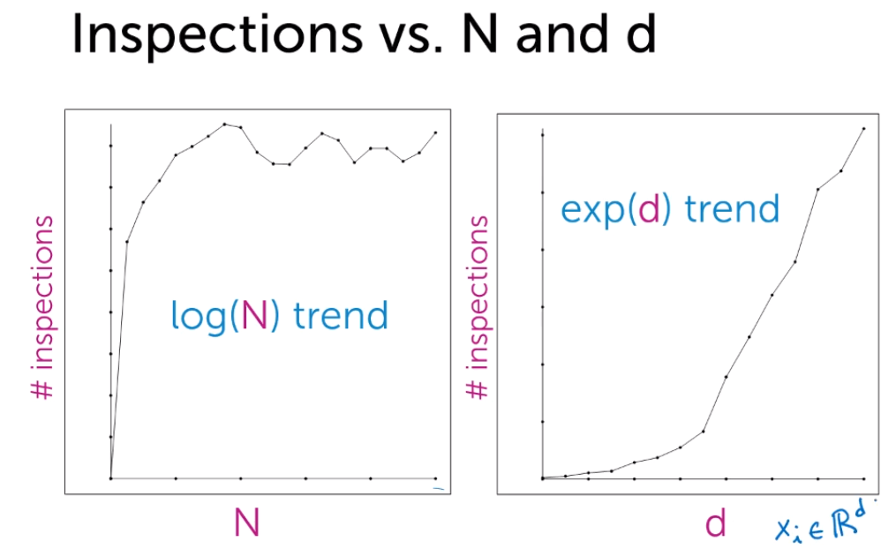
    - When dimensions (D) is high => KD-trees not very effective
  + KD tree limitations:
    - In general it is hard to implement them efficiently
    - Ineffective when we have many dimensions:
    - 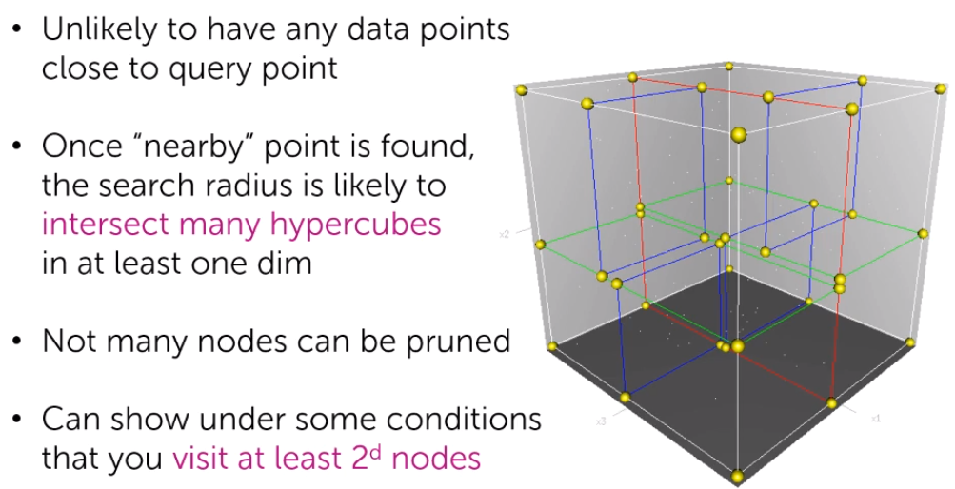
* Optimization / k-NN search Approximation:
  + Finding AN approximate nearest neighbour vs THE nearest neighbour can increase efficiency a lot! In practice should be good enough and there is no need to look for the closest neighbour
  + 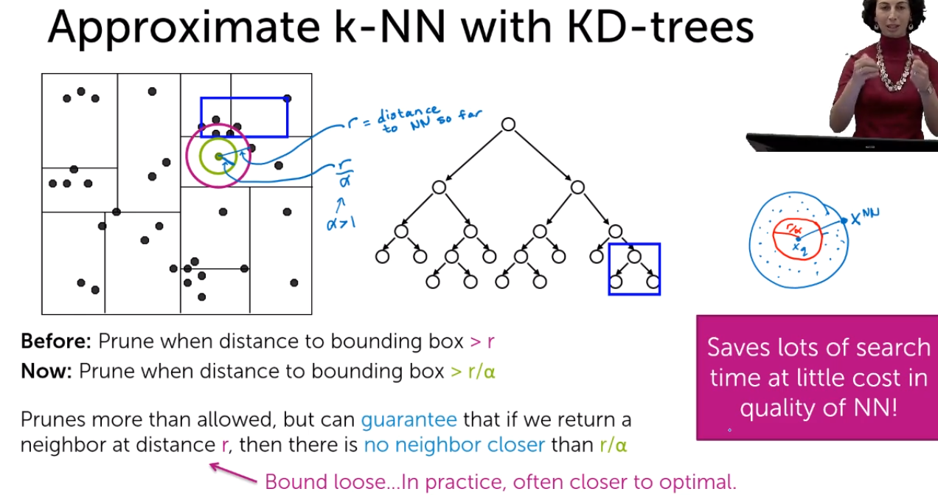
  + 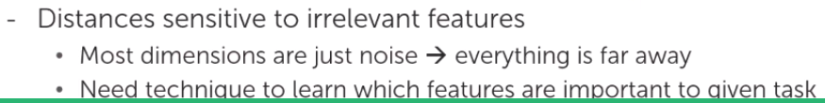
    - Dimensionality reduction would really help (e.g. L1 regularization)
* Locality sensitive hashing (LSH) as an alternative to KD-trees
  + Calculate scores and put point in bin 0 with score <0 and to bin 1 with scores >=0. Then we will look only for the NNs in the same bin
  + 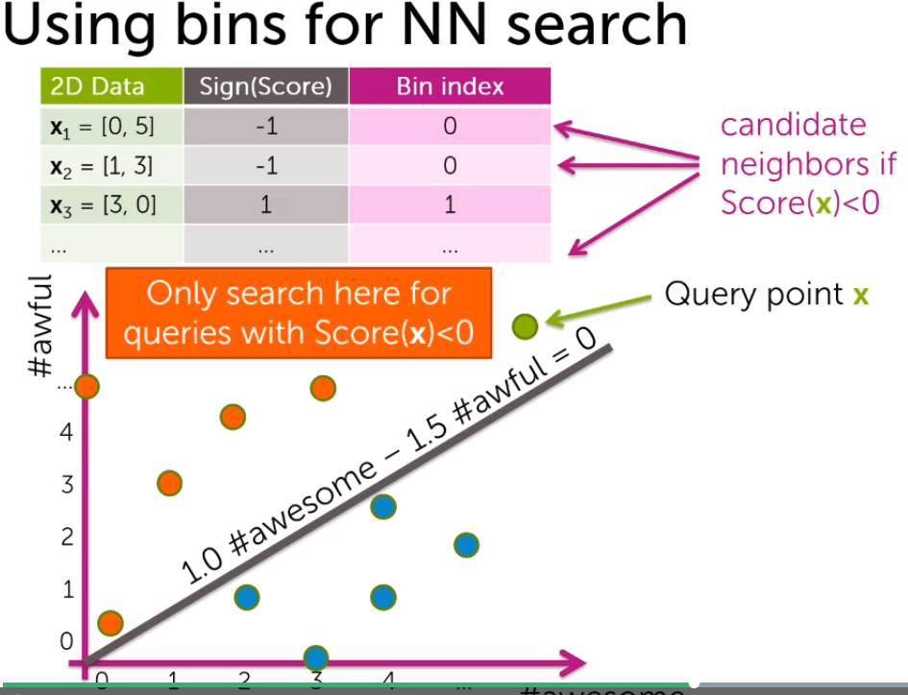
  + We store points in a Hash table
  + 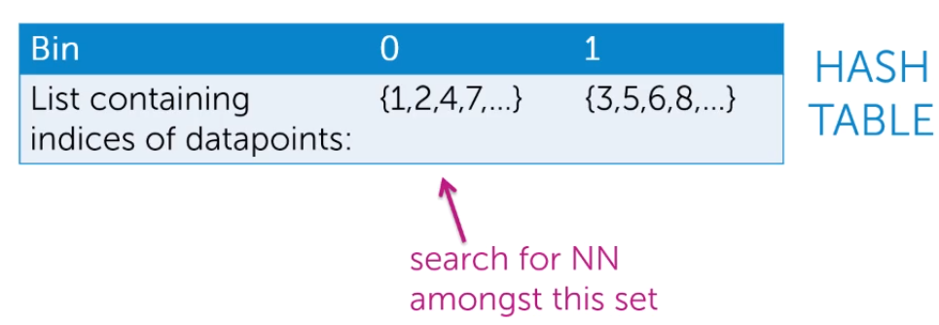
  + But it will provide only approximate search. We will miss the closest NN if it is in another bin
  + Challenges:
    - 1. How to find good line(s)?
    - 2. How to prevent close points to be separated in separate bins?
    - 3. Bin can contain a lot of points, so still a lot of brute force there
  + Solutions:
    - Draw line randomly! (covers Challenge 1 and 2). Actually it is very unlikely that a random line would separate close NNs into separate bins
    - 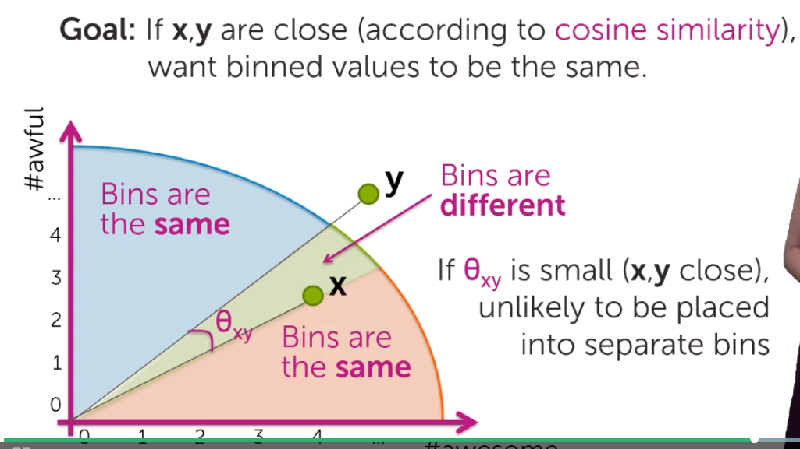
    - We can draw more lines and separate points in more bins! (thus cover cahllange 3)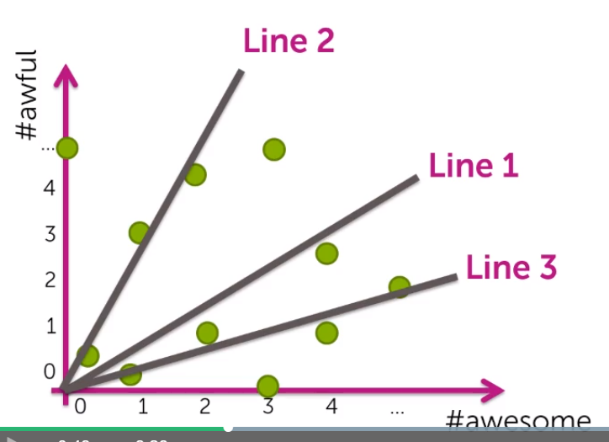
    - It is more likely that 2 NNs will be split in separate bins. However, we can look not just in one bin, but also in several bins nearby. (Still could be a problem if there are many lines separating 2NNs)
    - 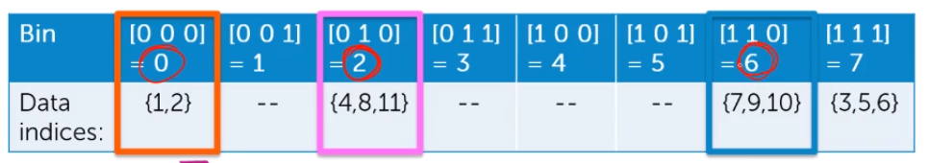
    - We will search until good approximation is found or while our computational budget is reached
    - We encode each bin and thus can effectively loop over those that are nearby
    - Instead of comparing various bins, we can make several independent hashtables and look at 1 bin in each. This can be computationally more effective in most cases.
    - 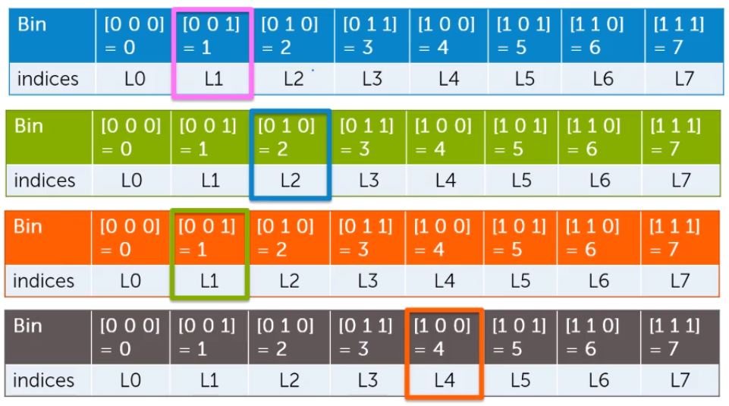
  + When we will do many queries, we should not worry much about the cost of building a LHS table or KD-tree, we should worry about the time to execute query
  + Many dimensions:
    - We will draw planes(hyperplane):
    - 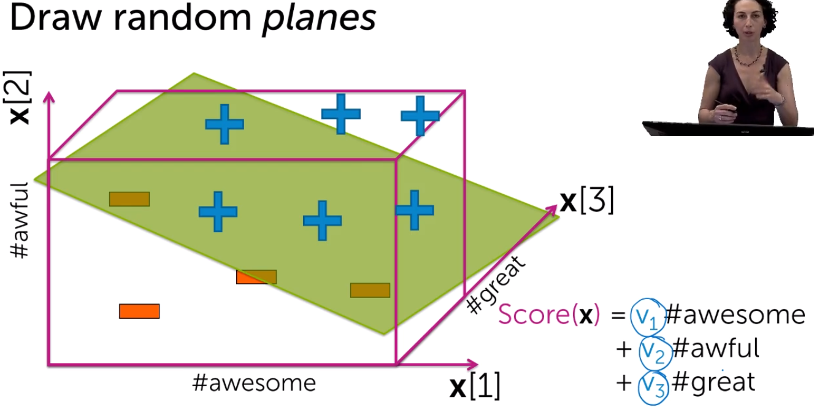

# Clustering – k-means

* K-means is the most popular clustering algorithm – we want to group items by their topics/features
* We do not have labels beforehand. Thus, clustering is an unsupervised learning. In the output we get to which cluster the record belongs
* What defines a cluster?
  + Center
  + Shaper/spread (circle or ellipse)
  + 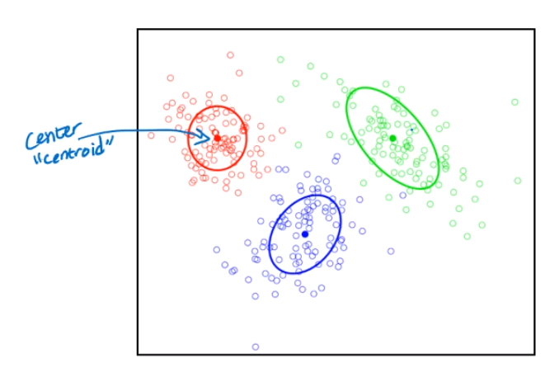
* We calculate score for each item to understand to which cluster i belongs:
  + 1) we can define score as the distance to the center of the cluster
* Clustering feasibility/complecity
  + 1) distance to center of a cluster might work: 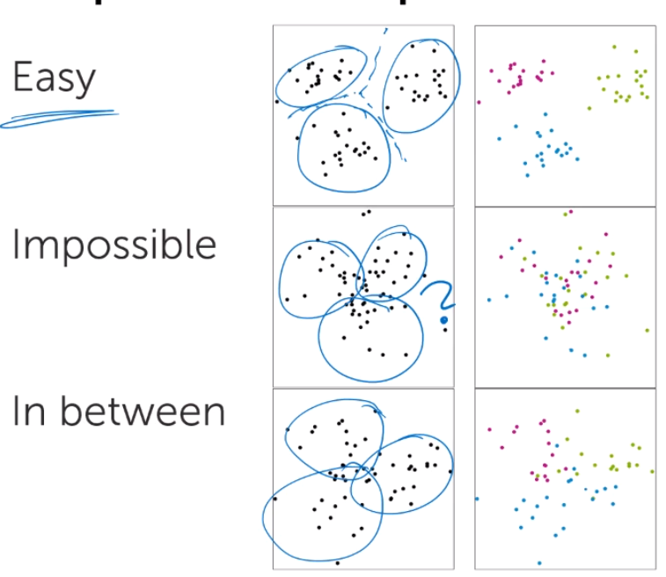
  + 2) distance to the center of a cluster would not work:
  + 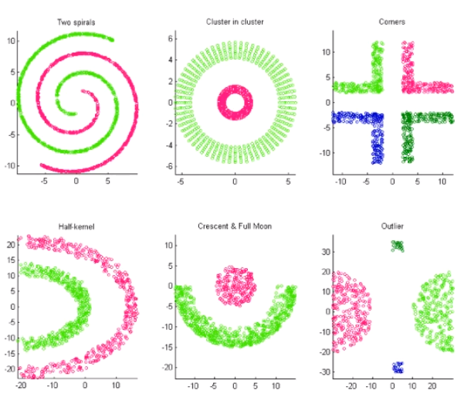
* K-means algorithm
  + For scoring we use the distance to the cluster center
  + Algo steps:
    - 1) initialize cluster centers
    - 2) assign observations to the clusters using the lowest distance to cluster center
    - 3) recalculate the cluster centers by calculating means of all observations in a given cluster
    - 4) repeat 2+3 until convergence
  + 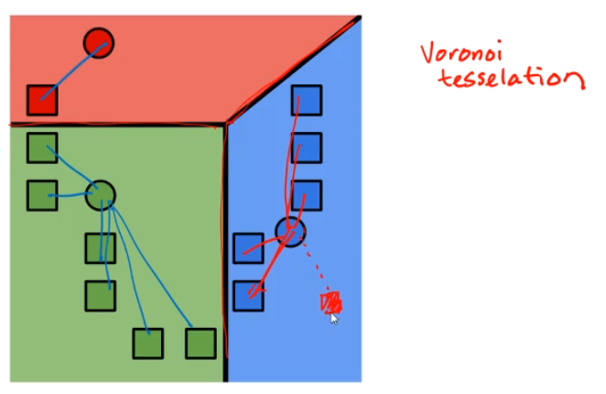(only for visualization, not used in algorithm)
  + 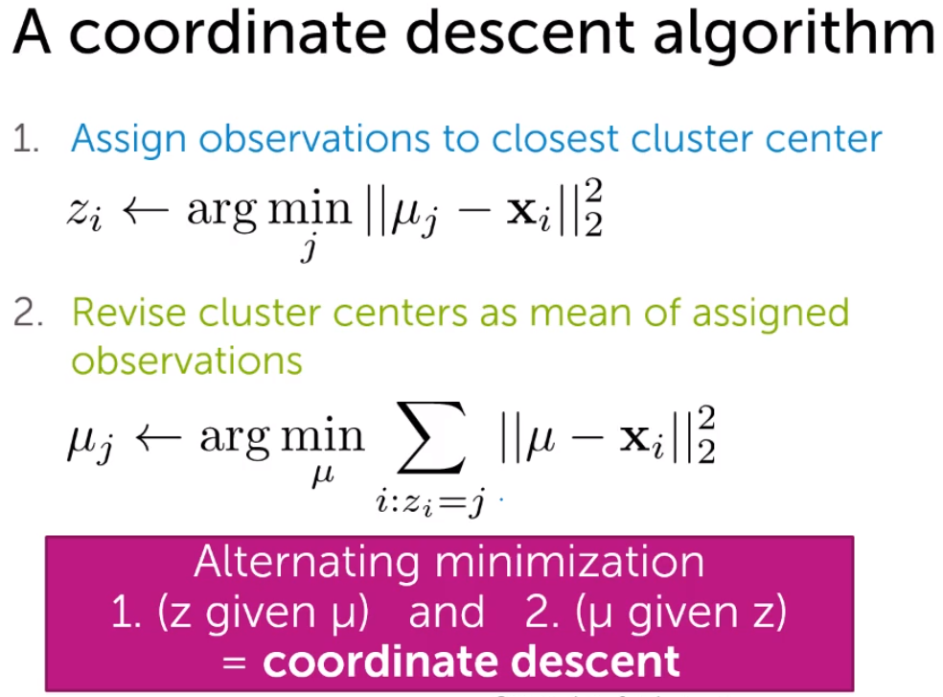
  + K-means convergest to local optimum
  + K-means really sensitive to initialization (+ are starting cluster centers):
    - 1.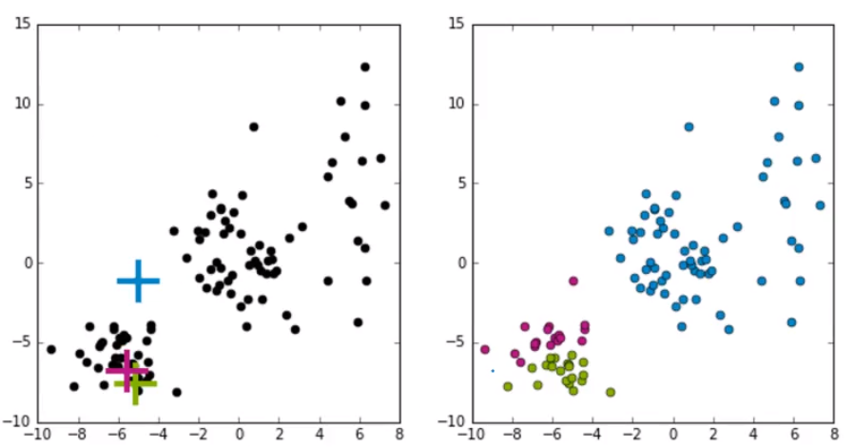
    - 2. 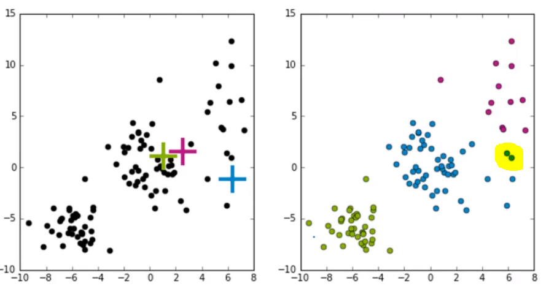
    - 3. 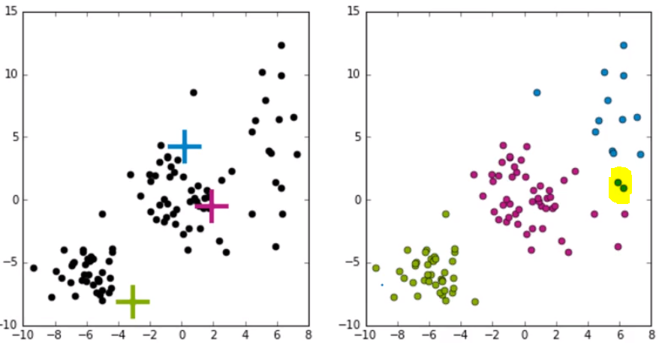
    - 2 and 3 looks similar, but 2 observations (in yellow) are assigned to different clusters
  + Smart initialization in k-means++ :
    - This method tries to spread out the initial set of centroids so that they are not too close together.
    - Algorithm:
      * 1) Choose the center of the first cluster randomly
      * 2) for each obs calculater the distance d(x) to the nearest cluster center
      * 3) choose the next cluster center among the data points that is furthest away from other cluster centers
      * 4) repeat stpes 2 and 3 until k centers are chosen
    - Computationaly costly relative to random initialization, but convergence is faster afterwards. Quality is better and lower runtime.
    - In general, you should run k-means at least a few times with different initializations and then return the run resulting in the lowest heterogeneity.
  + How to measure clustering quality? – use quality metrics metrics:
    - Calculate the sum of squared differences between data points and their cluster centers. The smaller distance, the better
    - 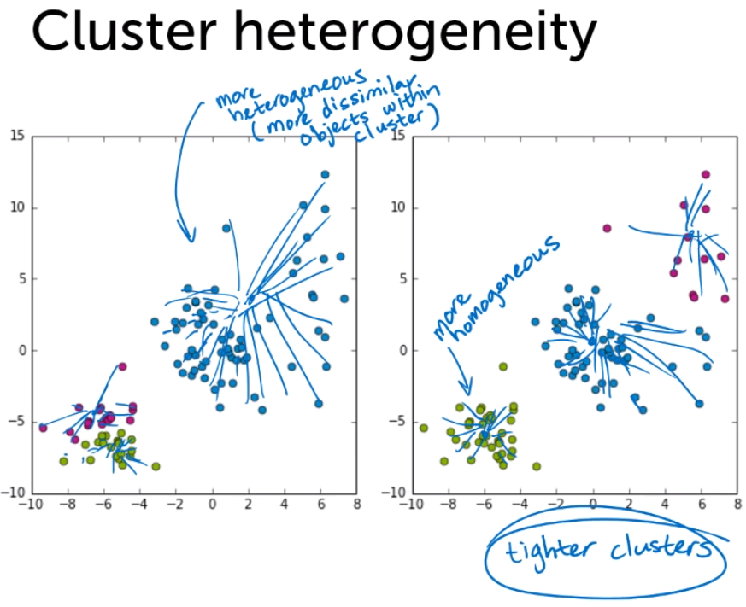
    - In general, heterogeneity (sum of squared differences) will decrease as k increases. In extreme case, when k=N (number of observations), we will have heterogeneity = 0, since each data point is a cluster and distances are all zeros
    - However, too many clusters is not informative. Thus, there is a trade-off between heterogeneity and number of clusters. In practice you can try different k, and see which gives better results

# Mixture models

* Sometimes data can belong not just to one cluster, as clusters might intersect. Also clusters can have such property as shape, and not just cluster center. Thus, we need some other algorithms for that. One such is Expectation Maximization (EM), there are other probabilistic approaches as well.
* Item belongs both to cluster 2 and 4 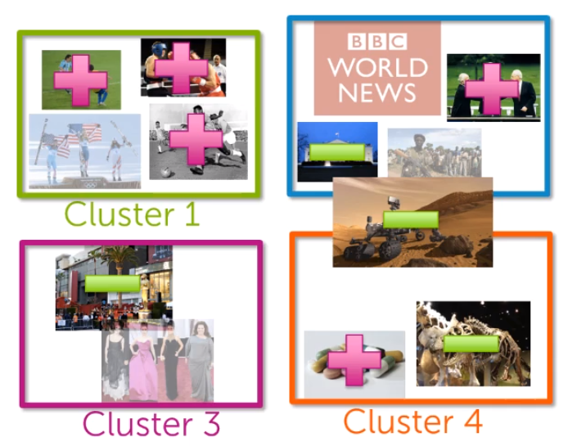
* K means assumes all clusters are the same size and shape: 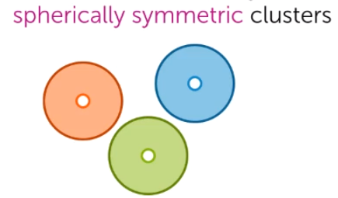
* It would not work with clusters of different size, shape and with overlapping clusters: 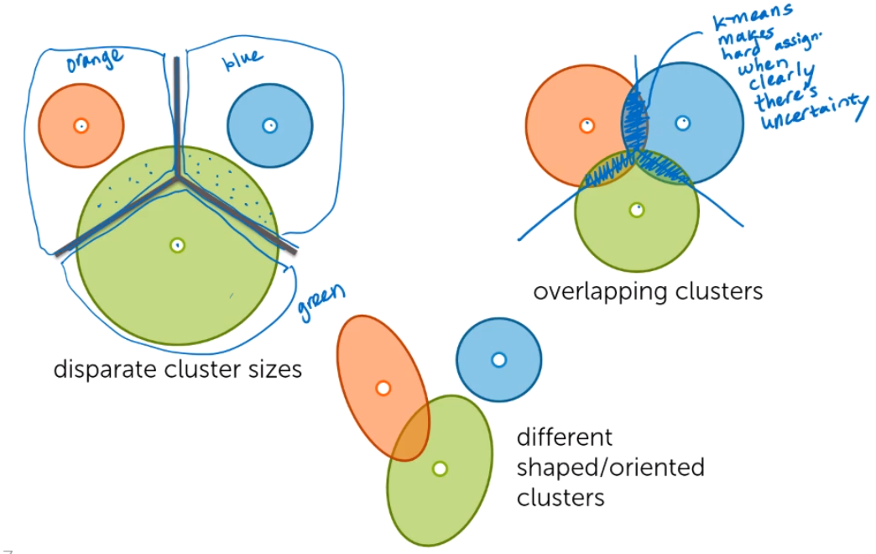
* To tackle that we need ‘soft’ or probabiistic assignments instead of ‘hard’ assignments. E.g. observation A belongs to cluster 1 with probability of 58%, cluster 2 – 40% and cluster 3 – 2%.
* Gaussians (Normal) distributions
  + 1D Gaussian. Distribution depends on mean and variance
  + 2D Gaussian. 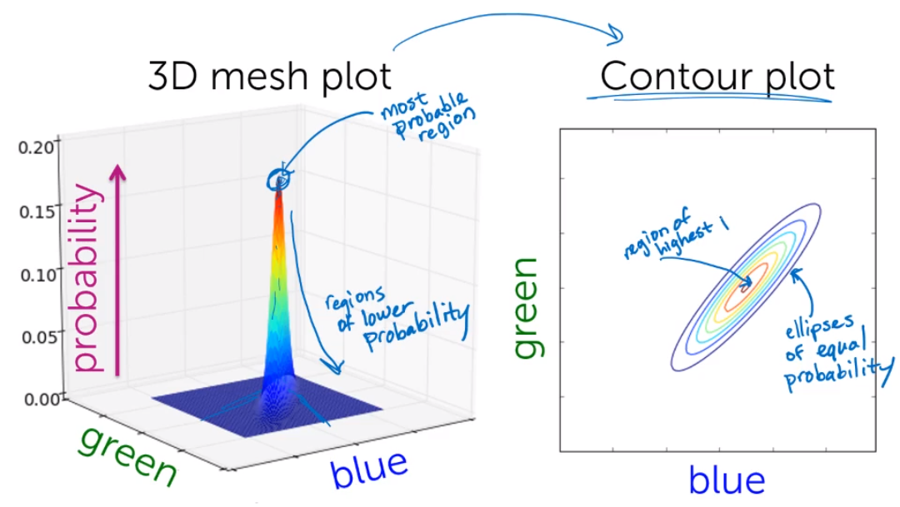
    - Distribution is defined by mean and covariance.
    - 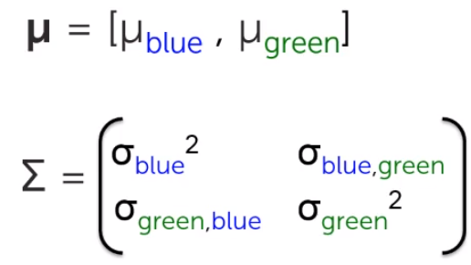
    - the first two are not correlated, the third has a positive correlation: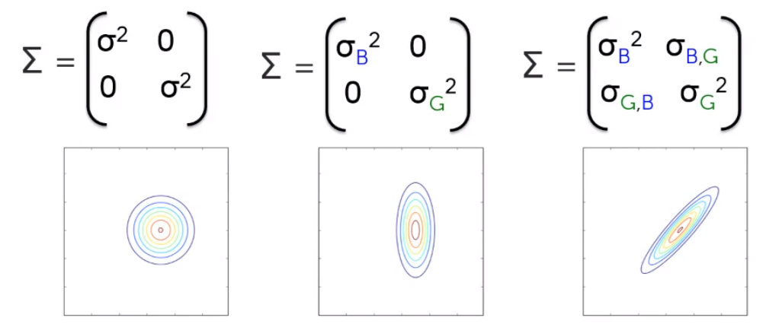
  + Multivariate Gaussian. Defined by mean vector and co-variance matrix

## Model – Mixture of Gaussians

* Example: we have 3 items to cluster – 1) forest (green color), 2) clouds (blue color), 3) sunset (red color). We will look how each color is distributed separately.
* 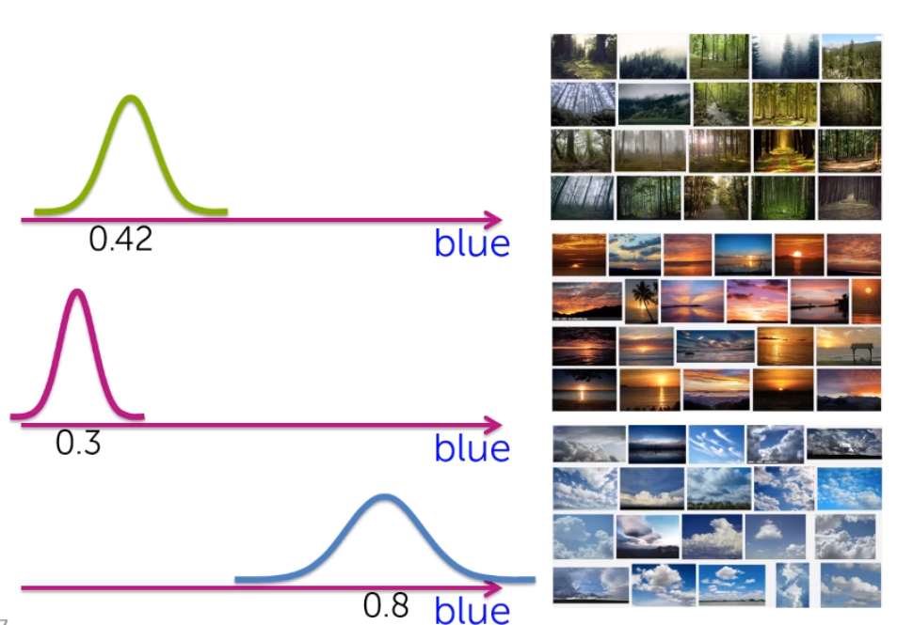
* Combined for blue: 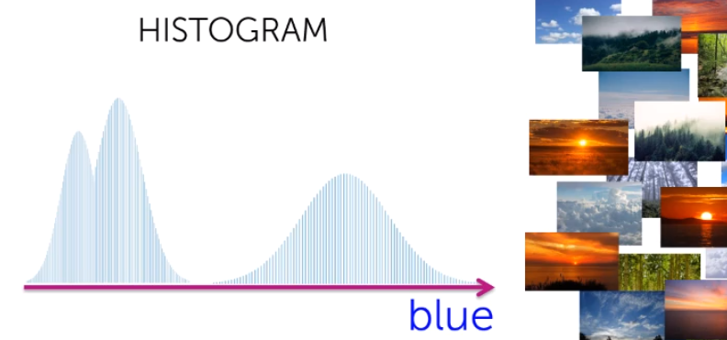
* We can weight more the distibution of more common items. E.g. if we have more forest pictures: 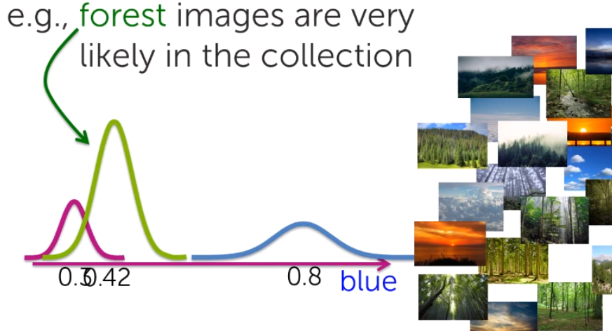
* 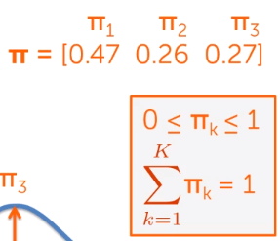. Where Pi’s are weights for each distributions. Weights sum up to 1.
* Now each distribution is characterized by means, variances and weights
* Probabilities:
  + 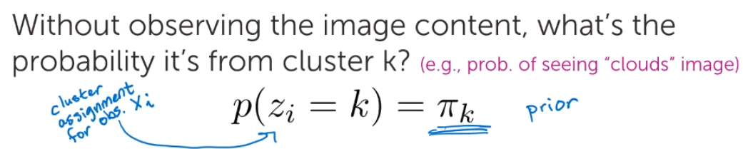
  + 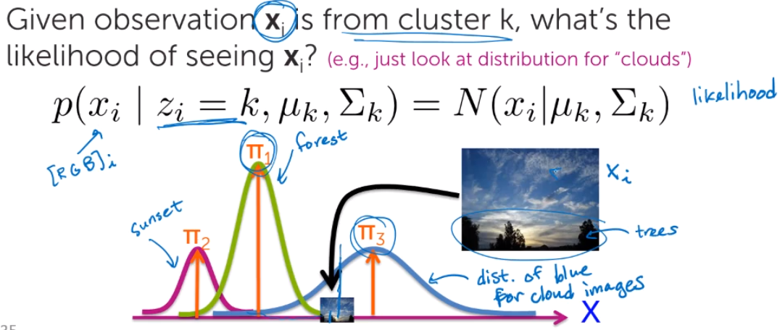(there is some uncertainty. Given pictures mainly belongs to ‘clouds’, but partly to ‘forests’ as well)
* In mixture model we have huge covariance matrix: 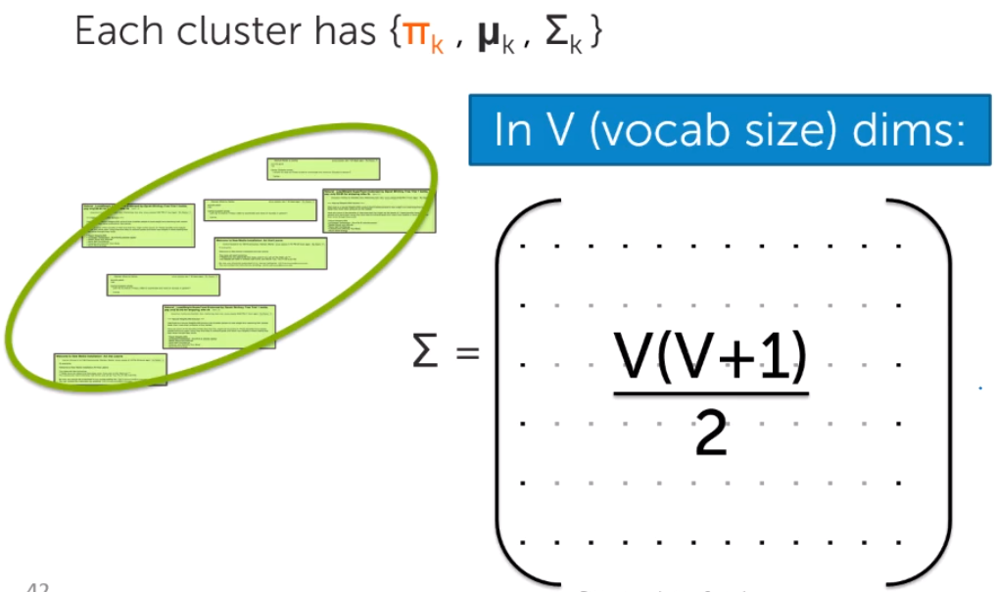 . ~V^2, where v is number of features. To, simplify calculations, we assume features are independent, thus we get a single diagonal in the covariance matrix, with all other elements being 0. 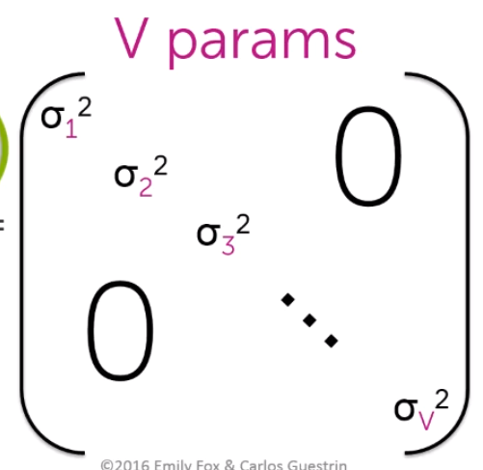

## Expectation maximization (EM). [EM of mixture of Gaussians as an algorithm]

* Part1 – cluster parameters are known
  + For each data point we calculate the probability that it belongs to a given cluster given cluster’s means, weights and covariances. For one datapoint we calculate the probabilities for each cluster. We call these probabilites as ‘responsibilites’.
  + 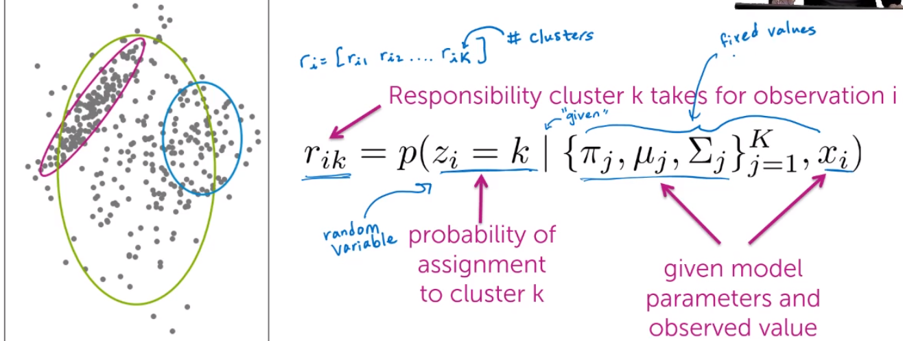
  + 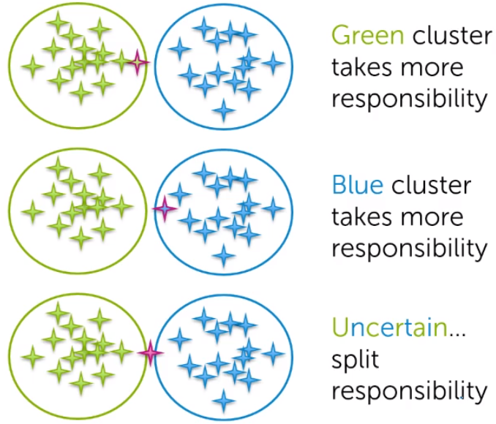
  + 
  + Thus there is a trade-off between distance to the cluster and size of the cluster. E.g. green cluster is much bigger, thus all points are more likely to be from that cluster, holding distance fixed
  + Calculating soft assignments (responsobilities/probabilities) is easy when cluster parameters 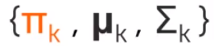 are known. But we do not know them!
* Part 2a – point ‘hard’ assignments to clusters are known, but we want to estimate parameters
  + We separately take points for each cluster. We simply calculate mean and covariance matrices, and cluster weights by using the given assigned points. (We do it independently for each cluster) 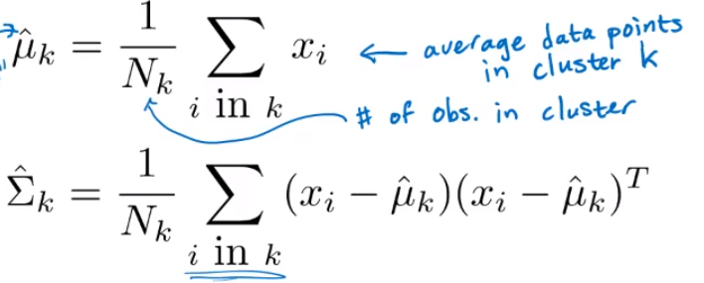
  + 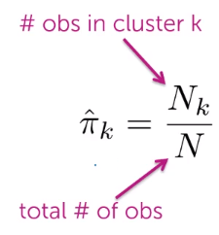
  + Estimating parameters of each cluster given ‘hard’ assignments is easy. However, we do not have assignments!
* Part 2b – point ‘soft’ assignments to clusters are given. Want to estimate parameters
  + Each point will have a weight for each cluster (e.g. 0.6 for cluster 1, 0.35 for cluster 2 and 0.05 for cluster 3). Using the soft assignments we calculate parameters independently for each cluster using the point weights. Instead of using number of points, we will use sum of weights of all the points in a given cluster 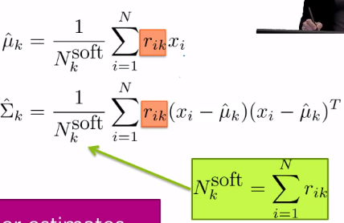
  + 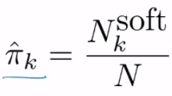
  + Again, if soft assignments are given, then it is easy to estimate cluster parameters
* EM algorithm
  + When we know cluster parameters, it is easy to estimate soft assignments. And vice versa, when soft assignment are known, it is easy to estimate cluster parameters. Thus, we can use iterative approach
  + Step0 – initialize cluster parameters (weigts, mean and covariance matrix)
  + Step1 – calculate cluster assignments (responsibilities) for each datapoint using given cluster parameters
  + Step2 – recalculate the cluster parameters with the assignments that have been just calculated
  + Repeat step 1 and step 2 until convergence. At each iteration calculate maximum likelyhood estimation (MLE). Convergence happens when MLE has increased less than the given threshold. Alternatively (or both) you can just repeat a specific number of iterations
  + 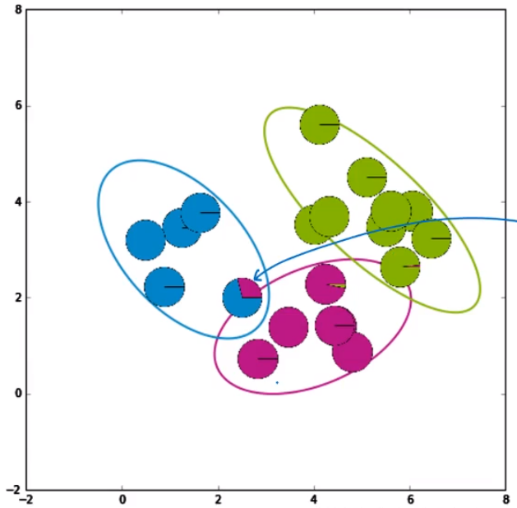I the end we still have points that belong to various clusters
* It is a coordinate ascent algorithm with convergence to local optimum (if we have L1 norm regularization). Also it means no step size to estimate
* Initialization:
  + 1) Random initialization
  + 2) Pick cluster centers sequentielly
  + 3) run k-means and use its final solutions as starting points for mixture model
* MLE can overfit the data:
  + Example from our wikipedia articles: In high dimensions, algorithm can cluster all documents by looking only at 1 word that has the same count or tidf value. It would focus only that feature.
  + 1) To tackle overfit, do not allow variances to get to 0. Add a small element to diagonal in a covariance matrix, thus it would not be 0
  + 2) add some pseudo elements to each cluster, that will bias our resuts and would prevent overfitting
  + 1) and 2) are somewhat similar to regularization
* Complexity:
  + EM of mixtures of models is much more flexible and give us much better clusters than k-means
  + However, there much more parameters to optimize.
  + Also it is much more computationally intensive

## Bayes rule

* P(A|B) = P(A)*P(B|A) / P(B)
* It is used in EM and some other probabilistic models